Software Requirements
Specification
Explore Nepal Travel & Tourism Website
Version 1.0 — Draft for review
Prepared by: Explore Nepal Project Team
Institution: [TBD]
Date: 9 October 2026
Technology: Python (framework and database TBD)
Prepared using the structure of the IEEE-style SRS template supplied by the project team.

Project Team Members
Team members and student ID numbers:
Team Member Name | Student ID
Bogati Mamata | 2401470
Bhusal Kalpana | 2401476
Tamang Sujina | 2401537
Bhatta Pabitra | 2401467
Mahato Amit Kumar | 2401455

Document Control
Item | Details
Project | Explore Nepal Travel & Tourism Website
Document | Software Requirements Specification
Version / status | 1.0 — Draft; requires team validation
Owner | Project team — TBD
Approval | Supervisor / client approval TBD

Revision History
Version | Date | Author | Reason for Change
1.0 | 9 Oct 2026 | Explore Nepal Project Team | Initial draft based on project summary and supplied template.

Table of Contents
- 1. Introduction
- 2. Overall Description
- 3. External Interface Requirements
- 4. System Features
- 5. Other Nonfunctional Requirements
- 6. Other Requirements
- Appendix A: Glossary
- Appendix B: Analysis Models
- Appendix C: To Be Determined List
Note: Update this list or insert Word's automatic Table of Contents before final submission.

1. Introduction

1.1 Purpose
This Software Requirements Specification defines the proposed requirements for Explore Nepal, a travel and tourism website intended to help visitors discover destinations, attractions, travel experiences, and practical travel information about Nepal. It describes system behavior, interfaces, constraints, quality requirements, and analysis models for version 1.0. This draft is based on the project brief; assumptions are marked and must be confirmed by the team.

1.2 Document Conventions
“Shall” and “must” indicate mandatory requirements; “should” indicates a desirable requirement; and “may” indicates an optional capability. Requirements have unique identifiers (FR-xx and NFR-xx). Priority is High, Medium, or Low. [ASSUMPTION] marks an unconfirmed assumption; [TBD] marks an undecided item.

1.3 Intended Audience and Reading Suggestions
Readers include the student development team, supervisor, testers, UI designers, content editors, and future maintainers. Read Sections 1–2 for context, Sections 3–4 for interfaces and functionality, Section 5 for quality/security requirements, and the appendices for diagrams, terminology, and unresolved decisions.

1.4 Product Scope
Explore Nepal will provide a browser-accessible guide to Nepal tourism. Visitors can browse and search destinations, inspect destination details and suggested itineraries, and submit travel inquiries. Authorized administrators can maintain destination/trip content and review inquiries. The intended benefits are easier destination discovery, organized travel information, and a contact channel for interested travelers.
[ASSUMPTION] Version 1.0 is an informational website with inquiry submission, not a full payment-processing or confirmed reservation platform. Online payments, live availability, reviews, user accounts, and third-party booking integrations are outside confirmed scope until approved.

1.5 References
- User-supplied “Software Requirements Specification” template (IEEE-style / Karl E. Wiegers template), 8 pages.
- Project brief: “Travel and tourism website”; description “explore Nepal”; technology stack “python”.
- IEEE 29148 requirements engineering guidance may be consulted if required by the course; exact edition/citation is TBD.
No external API, design guide, or regulatory reference was specified.

2. Overall Description

2.1 Product Perspective
Explore Nepal is proposed as a new, self-contained web application. A browser frontend communicates over HTTPS with a Python application. The application validates requests, reads/writes content and inquiry records in a database, and returns pages or responses. Administrative functions require authentication. Python framework, database, hosting, and deployment architecture are TBD.
Component | Responsibility
Visitor browser / UI | Render listings, search, destination pages, forms, and confirmations.
Python web application | Route requests, validate input, apply rules, enforce permissions, and coordinate data access.
Database | Persist destinations, itineraries, inquiries, and administrator account data.
Admin interface | Manage destination and trip content and review inquiries.
Optional email service | Send inquiry notifications/confirmations if enabled; provider TBD.

2.2 Product Functions
- Display a home page and curated Nepal destinations.
- Browse destinations by category, region, activity, or approved attributes.
- Search and filter destination records.
- Display destination details, highlights, practical information, and related itineraries.
- Accept and validate travel inquiries.
- Store inquiries and show confirmation; optionally notify administrators.
- Authenticate administrators and enforce permissions.
- Create, edit, publish, unpublish, and archive destination and itinerary content.
- Review inquiries and update inquiry status.
- Provide responsive layouts, accessible labels, and clear error messages.

2.3 User Classes and Characteristics
User class | Characteristics / permissions
Visitor / tourist | Primary user; usually anonymous; browses, searches, views content, submits inquiries.
Administrator / content manager | Authenticated trusted user; manages content and inquiries.
Tour operator / tourism partner | [ASSUMPTION] May receive/respond to inquiries if role is approved; permissions TBD.
Developer / maintainer | Maintains code, deployment, backups, and security updates.

2.4 Operating Environment
- Client: modern desktop and mobile browsers; minimum versions TBD.
- Server: OS/hosting TBD; must support selected Python runtime and framework.
- Backend: Python; framework (Django, Flask, or FastAPI) TBD.
- Database: relational database recommended; exact engine TBD.
- Production network traffic shall use HTTPS.

2.5 Design and Implementation Constraints
- Python is the only confirmed implementation technology; framework, versions, ORM, and database are TBD.
- Separate presentation, business logic, and persistence where practical.
- Production secrets must not be committed to GitHub.
- Travel content must be reviewed by the designated content owner; freshness policy TBD.
- Applicable privacy obligations and institutional policies must be identified before production release.
- Student-project scope may limit live booking, payments, and third-party integrations.

2.6 User Documentation
- Visitor FAQ/help page covering search, destination pages, and inquiry submission.
- Administrator guide for sign-in, content publishing, and inquiry management.
- GitHub README with setup, environment variables, database initialization, tests, and deployment.
- Documentation language and format TBD; English is assumed for version 1.0.

2.7 Assumptions and Dependencies
- [ASSUMPTION] Destination and itinerary information will be supplied or approved by the team.
- [ASSUMPTION] Core browsing works without visitor accounts.
- [ASSUMPTION] An inquiry is not a binding booking and does not guarantee availability or price.
- [ASSUMPTION] Administrators are provisioned by the team; public admin registration is not allowed.
- [TBD] Framework, database, hosting, email provider, domain, analytics, and external API choices.
- [TBD] Whether favorites, reviews, accounts, maps, live booking, or payments are included.
- [TBD] Content languages, expected traffic, retention period, and support ownership.

3. External Interface Requirements

3.1 User Interfaces
The site shall provide consistent navigation, clear page titles, readable destination cards, search/filter controls, and a footer with contact and policy links. Layouts shall adapt to desktop and mobile widths. Forms shall label fields, indicate required fields, show field-specific validation messages, and preserve safe input after validation errors.
- Public pages: Home, Destinations, Destination Details, Itineraries/Guides, About, Contact/Inquiry, FAQ, Privacy Notice.
- Admin pages: Dashboard, Destination Management, Itinerary Management, Inquiry List, Inquiry Details, Admin Login.
- Messages shall be actionable and shall not expose stack traces or internal system details.
- Branding, colors, wireframes, and supported languages are TBD.

3.2 Hardware Interfaces
No specialized hardware interface is required. Users need a device with a supported browser and internet access. Server sizing shall be chosen after expected traffic and performance targets are confirmed.

3.3 Software Interfaces
Interface | Data exchanged | Purpose / status
Browser ↔ Python app | HTTP requests; HTML or JSON responses | Primary visitor/admin interaction; HTTPS in production.
Python app ↔ database | Queries/transactions for content, users, inquiries | Database engine/schema TBD.
App ↔ email provider | Notification message and delivery status | Optional dependency; provider TBD.
GitHub / CI | Source, dependency manifests, tests, docs | Repository URL and CI workflow TBD.

3.4 Communications Interfaces
Use HTTP in local development and HTTPS in production. Form submissions shall use standard web request methods and server-side validation. If email is configured, authenticated transport shall be used and credentials shall not be stored in source control. API formats, rate limits, retries, and notification guarantees are TBD.

4. System Features

4.1 Destination Browsing and Discovery
Description and Priority: High. Visitors open the home page or destination list; the system displays published destinations and detail pages. Empty catalog states show a helpful message.
Stimulus/Response Sequence: Visitors open the home page or destination list; the system displays published destinations and detail pages. Empty catalog states show a helpful message.
Functional Requirements:
- FR-01: The system shall display a home page with navigation and featured Nepal destinations.
- FR-02: The system shall show only published destination records to public visitors.
- FR-03: A destination page shall show its name, region, description, highlights, images if available, and configured practical information.
- FR-04: The system shall show a helpful empty-state message when no destinations are available.
- FR-05: Related itineraries/destinations shall be shown when relationships exist; otherwise the section may be omitted.

4.2 Search and Filtering
Description and Priority: High. Visitors enter a keyword or choose filters; the system returns matching published records and permits clearing filters.
Stimulus/Response Sequence: Visitors enter a keyword or choose filters; the system returns matching published records and permits clearing filters.
Functional Requirements:
- FR-06: The system shall search approved destination fields such as name, region, and description.
- FR-07: The system shall provide only filters supported by stored data, such as region, activity, or destination type.
- FR-08: The system shall combine active filters consistently and show the active filter state.
- FR-09: The system shall show a no-results message and a way to modify or clear search criteria.
- FR-10: The system shall safely handle empty, long, or malformed search input without exposing internal errors.

4.3 Itineraries and Travel Guides
Description and Priority: Medium. Visitors open a guide and read its route, duration, activities, and notes when available.
Stimulus/Response Sequence: Visitors open a guide and read its route, duration, activities, and notes when available.
Functional Requirements:
- FR-11: The system shall list published itineraries or guides if the module is enabled.
- FR-12: An itinerary page shall show title, duration, route/stops, description, and practical notes when supplied.
- FR-13: Suggested itineraries shall be labeled informational and shall not imply live availability or guaranteed pricing.

4.4 Travel Inquiry Submission
Description and Priority: High. Visitors submit a form; the system validates and stores it, then confirms success.
Stimulus/Response Sequence: Visitors submit a form; the system validates and stores it, then confirms success.
Functional Requirements:
- FR-14: The system shall provide an inquiry form with configurable contact fields and a message field.
- FR-15: The system shall validate required fields and formats on client and server sides.
- FR-16: The system shall reject invalid submissions with field-specific messages and shall not store them as valid inquiries.
- FR-17: The system shall store accepted inquiries with a unique identifier, timestamp, and initial status.
- FR-18: After storage, the system shall confirm receipt and state that the inquiry is not a confirmed booking.
- FR-19: The system should notify an administrator of new inquiries if email notification is configured.
- FR-20: The system shall implement basic anti-spam protection appropriate to the framework and hosting.

4.5 Administrator Authentication and Authorization
Description and Priority: High. An administrator signs in; the system verifies credentials and protects admin functions.
Stimulus/Response Sequence: An administrator signs in; the system verifies credentials and protects admin functions.
Functional Requirements:
- FR-21: The system shall require authentication before allowing administrative actions.
- FR-22: Passwords shall use a modern salted hash provided by a trusted framework/library; plaintext passwords shall never be stored.
- FR-23: The system shall deny unauthorized access to protected routes and data.
- FR-24: The system shall provide logout that invalidates the active session.
- FR-25: The system shall not permit public self-registration for administrator privileges.

4.6 Content Management
Description and Priority: High. An authenticated administrator creates/edits content, validates it, and publishes or unpublishes it.
Stimulus/Response Sequence: An authenticated administrator creates/edits content, validates it, and publishes or unpublishes it.
Functional Requirements:
- FR-26: An administrator shall create, edit, publish, unpublish, and archive destination records.
- FR-27: An administrator shall create and edit itinerary/guide records if the module is enabled.
- FR-28: The system shall validate required content fields before publishing.
- FR-29: The system should record creation/update timestamps and responsible admin identity.
- FR-30: Unpublished or archived content shall not appear in public listings or search results.

4.7 Inquiry Management
Description and Priority: Medium. An administrator reviews submitted inquiries and updates their processing status.
Stimulus/Response Sequence: An administrator reviews submitted inquiries and updates their processing status.
Functional Requirements:
- FR-31: An administrator shall list and inspect submitted inquiries.
- FR-32: An administrator shall update inquiry status using a configured set, such as New, In Progress, Responded, or Closed.
- FR-33: Inquiry details shall be restricted to authorized users and not exposed on public pages.
- FR-34: The system should support filtering inquiries by date, status, or reference identifier.

4.8 Use Case Diagram
The diagram summarizes visitor and administrator interactions. Tour-operator functionality is an optional assumption and must be confirmed or removed by the team.
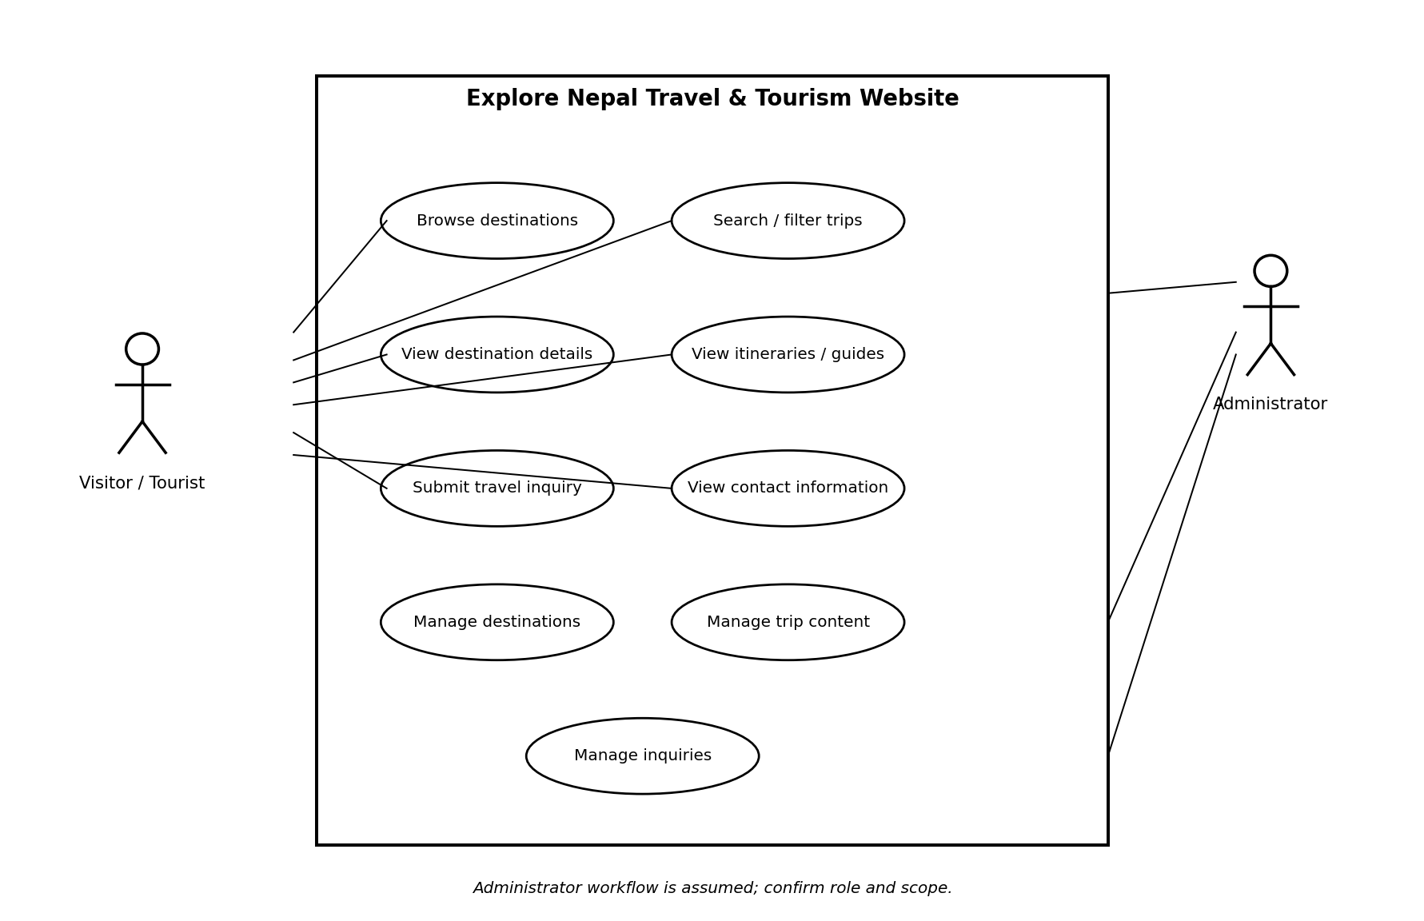

4.9 Sequence Diagram — Search and View Destination
Successful search flow. If no records match, the application returns an empty result and the UI displays a no-results message.
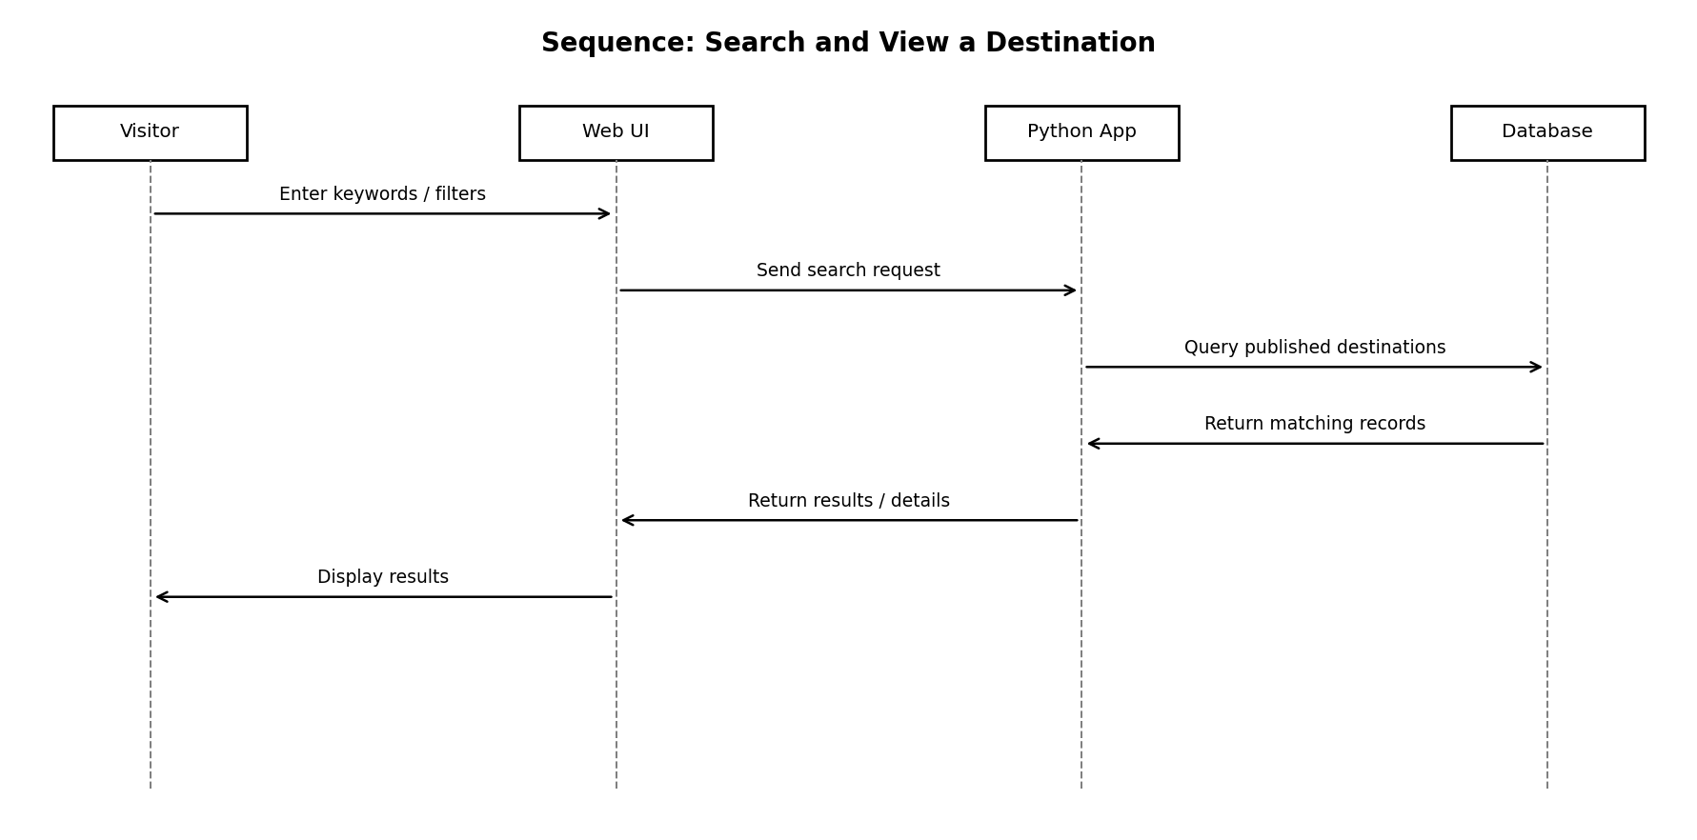

4.10 Sequence Diagram — Submit Travel Inquiry
The flow assumes server-side validation and persistent storage. Administrator notification is optional and depends on email configuration.
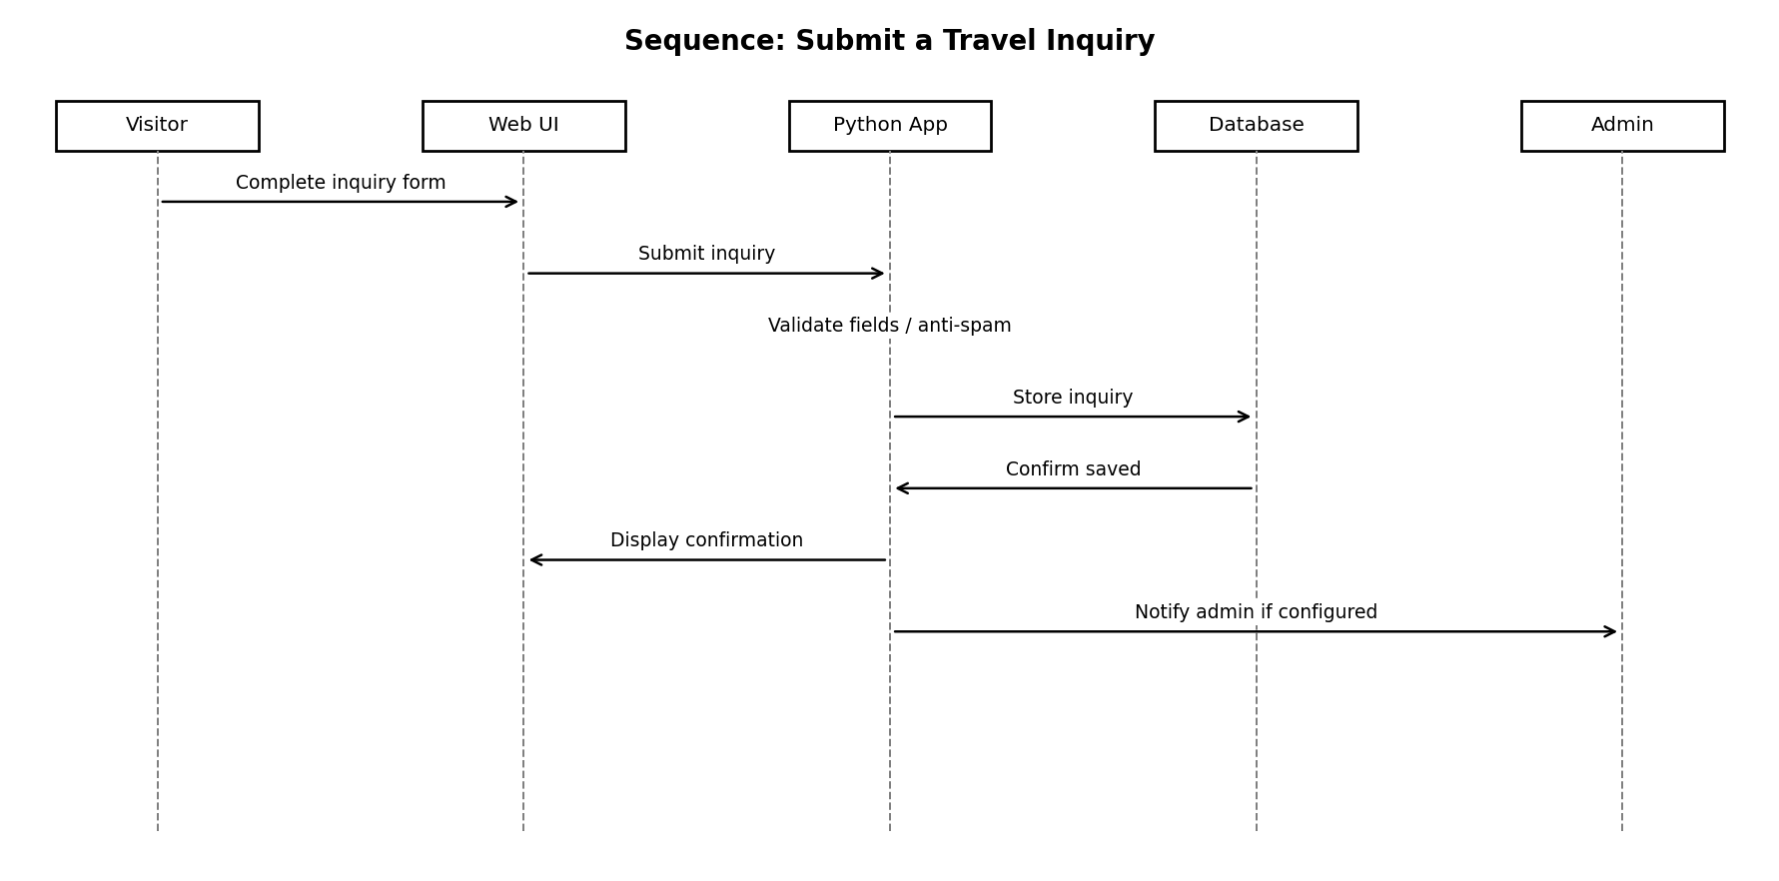

5. Other Nonfunctional Requirements

5.1 Performance Requirements
- NFR-01: Under a reference load of 50 concurrent visitors, 95% of ordinary page requests should complete within 3 seconds, excluding third-party delays. [TARGET; validate in test environment].
- NFR-02: Search should return results within 2 seconds for up to 10,000 destination/itinerary records in the agreed test environment. [TARGET].
- NFR-03: Images shall be optimized; long lists should use pagination or incremental loading.
- NFR-04: Long-running form submissions should show progress/disabled-submit state and prevent duplicate submissions where feasible.

5.2 Safety Requirements
- NFR-05: Travel information shall be labeled as subject to change; visitors should verify current conditions, permits, and official guidance before travel.
- NFR-06: An inquiry shall not be presented as a confirmed booking, ticket, permit, or service guarantee.
- NFR-07: Safety guidance, if shown, shall be reviewed by the content owner and include a last-reviewed date where feasible. Content policy TBD.

5.3 Security Requirements
- NFR-08: Production traffic shall use HTTPS.
- NFR-09: Server-side validation and parameterized database access or a trusted ORM shall be used.
- NFR-10: The application shall apply output escaping and protections against common vulnerabilities such as XSS and CSRF where applicable.
- NFR-11: Admin routes and inquiry records shall require authorization; visitors shall not access private inquiries.
- NFR-12: Secrets and production values shall be stored outside source code and excluded from version control.
- NFR-13: Only personal data needed to answer an inquiry shall be collected; a privacy notice shall explain purpose and contact method.
- NFR-14: Admin access should be logged without recording passwords or unnecessary sensitive form contents.
- NFR-15: Inquiry data retention and deletion rules shall be defined before production. [TBD].

5.4 Software Quality Attributes
- NFR-16 Usability: In testing, a first-time visitor should reach a destination page from the home page within three navigation actions.
- NFR-17 Accessibility: Use semantic headings, keyboard-operable controls, image alternatives, and form labels. Formal WCAG target TBD.
- NFR-18 Compatibility: Core functions shall work in agreed current desktop/mobile browsers; exact support matrix TBD.
- NFR-19 Maintainability: Separate routes/controllers, business logic, data access, templates/static assets, and configuration where practical.
- NFR-20 Reliability: Log server errors with timestamps and show friendly error pages instead of raw stack traces.
- NFR-21 Testability: Automated tests should cover search, validation, authorization, publication state, and inquiry storage.
- NFR-22 Portability: Environment-based configuration shall support local execution and deployment without hard-coded machine-specific paths.

5.5 Business Rules
- BR-01: Only published destinations and guides are visible to anonymous visitors.
- BR-02: Only authorized administrators may manage content or inspect inquiry details.
- BR-03: An inquiry is a request for follow-up, not a confirmed reservation or contract.
- BR-04: Required fields and accepted values shall be validated before records are saved.
- BR-05: Content accuracy and update frequency are the responsibility of the designated content owner; review process TBD.
- BR-06: A tour-operator account/assignment workflow is optional and requires approval before implementation.

6. Other Requirements

6.1 Data Requirements
Expected entities include Destination, Itinerary/Guide, Inquiry, Administrator/User, and optional Media/Category. Exact field types, relationships, deletion rules, and migrations are TBD. Content records should have a stable identifier, title/name, publication state, and timestamps. Inquiry records should include a reference, timestamp, contact information, message, and status.

6.2 Backup and Recovery
Before production use, define backup frequency, retention, restore procedure, and responsible owner. These values are TBD. Uploaded images and external content files must be included in backup planning.

6.3 Localization and Content
English is assumed for version 1.0. Nepali, Korean, or other languages, currency display, date formats, and translated content are TBD.

6.4 Deployment and Repository
The GitHub repository should include source code, dependency manifest, schema/migrations, tests, README, example environment configuration with placeholders, and this SRS. It must not include credentials, API keys, production data, or private inquiry exports. Repository URL and release process are TBD.

Appendix A: Glossary
Term | Definition
SRS | Software Requirements Specification.
Visitor | User of public site features, usually without signing in.
Administrator | Authorized user who manages content and inquiries.
Destination | A Nepal location or attraction represented by a content record.
Itinerary | Suggested sequence of destinations or activities.
Inquiry | Visitor request for information; not a confirmed booking.
Functional requirement | Capability or behavior the system must provide.
Nonfunctional requirement | Quality, constraint, or operational requirement.
TBD | To be determined; a decision or value not yet supplied.

Appendix B: Analysis Models
B.1 Use case diagram
B.2 Sequence diagram — Search and view destination
B.3 Sequence diagram — Submit travel inquiry

Appendix C: To Be Determined List
ID | Open question / decision | Suggested owner
TBD-01 | Team member names, author, institution, supervisor, approval date. | Team lead
TBD-02 | Python version and framework (Django / Flask / FastAPI). | Technical lead
TBD-03 | Database, hosting, domain, deployment architecture. | Technical lead
TBD-04 | Final scope: accounts, favorites, reviews, maps, booking, payments, tour-operator role. | Team / supervisor
TBD-05 | Inquiry fields, email provider, anti-spam, response workflow. | Product owner
TBD-06 | Content sources, editorial review process, update frequency. | Content lead
TBD-07 | Languages, accessibility target, browser support matrix. | UI lead
TBD-08 | Expected traffic, performance environment, acceptance thresholds. | Test lead
TBD-09 | Privacy notice, retention/deletion, backups and recovery objectives. | Team / supervisor
TBD-10 | GitHub URL, CI setup, deployment process, document approval. | Team lead
End of Software Requirements Specification.

System Context Model
The context model defines the boundary of the Explore Nepal website and shows the people and external systems that exchange information with it. The website is the central system. Tourists/visitors use it to discover Nepal destinations and submit enquiries; administrators maintain destination and website content. Optional map/location and email/notification services may be integrated if approved and available.
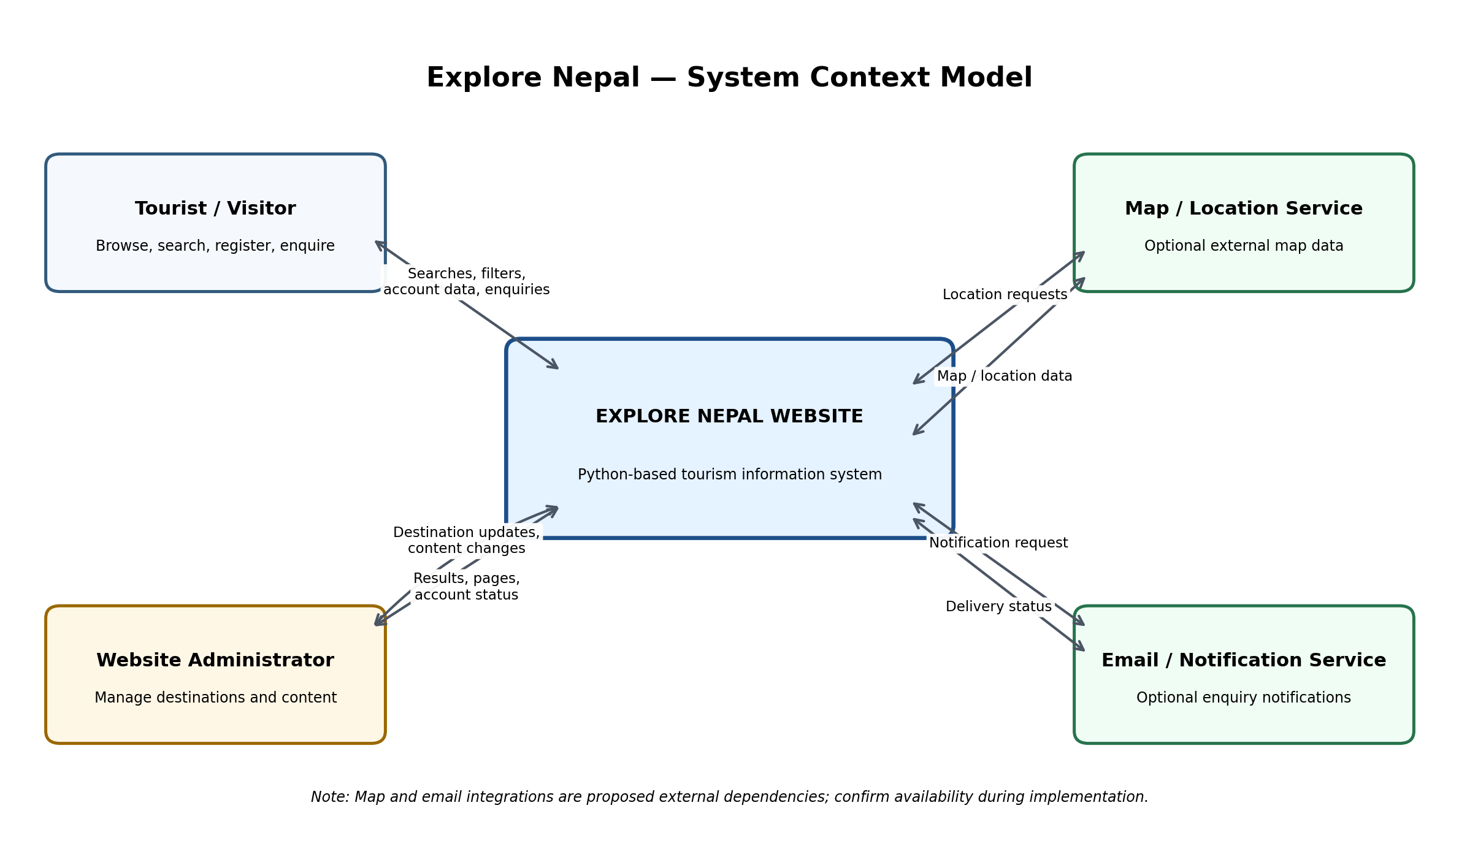
Figure: Explore Nepal System Context Diagram

External Entities and Information Flows
External entity | Information sent to the website | Information received from the website
Tourist / Visitor | Search terms, filters, registration/login details, enquiries | Destination details, search results, pages, account status, enquiry acknowledgement
Website Administrator | Destination records, images, article/content edits, moderation actions | Admin pages, validation messages, saved/updated status
Map / Location Service (optional) | Map tiles, coordinates, or location information | Location/map requests, if the integration is implemented
Email / Notification Service (optional) | Delivery status or error response | Notification request for an enquiry or account event, if implemented

Context Model Assumptions and Constraints
- The Explore Nepal website is the system boundary; external map and email providers are outside that boundary.
- The Python technology choice is specified by the project brief; the specific Python framework and hosting platform remain TBD.
- Map/location and email/notification integrations are optional proposals, not confirmed implemented features.
- Online booking, payment processing, and live availability are not included unless the team and professor explicitly approve them.

Items to Confirm (TBD)
- Confirm whether the website will use an external map/location API.
- Confirm whether enquiry notifications will be sent by email and select a provider if required.
- Confirm whether user registration and login are in the final project scope.

